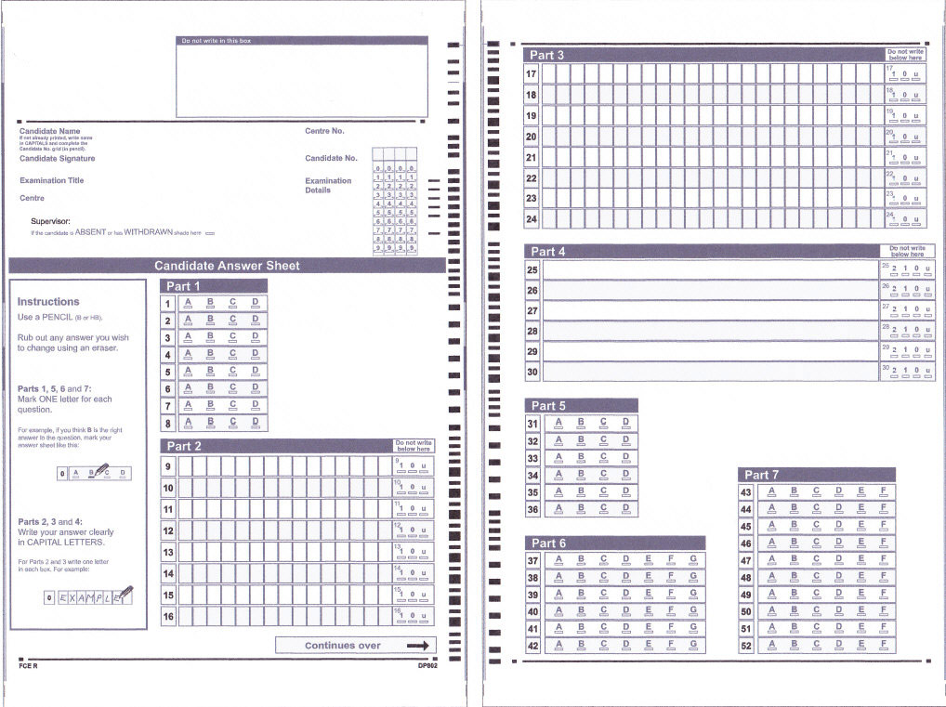

Weekly test ...... Reading and Use of English .........

Name:

Date:

Result:

